Module 6 In-Class Activity
Ariel Garcia Delgado
Miami Dade College
COP2800 Java Programming
Dr. Martins Idahosa
June 15, 2026

Modular Java Programming with Methods: Eggs Calculator

Introduction
The purpose of this in-class activity was to complete a modular Java program named Eggs.java. The program calculates the price of an order of eggs for Meadowdale Dairy Farm. The farm sells eggs for $3.25 per dozen and $0.45 per loose egg. A loose egg is any egg that is not part of a complete dozen.
For this submission, I completed Program A, Eggs.java. The instructor clarified that the second program, Percentages.java, was not required for this submission. The completed Eggs program prompts the user for a number of eggs, validates the input, calculates the number of full dozens and loose eggs, calculates the total cost, and prints a full explanation of the order.

Implementation and Method Choices
The program uses constants to store the prices for a dozen eggs and for one loose egg. This makes the program easier to maintain because the prices are written once at the top of the class. If the farm changes a price later, only the constant value needs to be updated.
private static final double PRICE_PER_DOZEN = 3.25;
private static final double PRICE_PER_LOOSE_EGG = 0.45;
The calculateDozens method receives the total number of eggs as an integer parameter and returns the number of complete dozens. It uses integer division by 12 because a dozen contains 12 eggs and any remainder should not be counted as a full dozen.
public static int calculateDozens(int eggs) {
return eggs / 12;
}
The calculateLooseEggs method also receives the total number of eggs, but it returns the number of eggs left over after complete dozens are counted. This method uses the modulo operator, which gives the remainder after division by 12.
public static int calculateLooseEggs(int eggs) {
return eggs % 12;
}
The calculateTotalCost method receives two values: the number of dozens and the number of loose eggs. It multiplies the dozens by the dozen price, multiplies the loose eggs by the loose-egg price, and adds both amounts together to return the final cost as a double.
public static double calculateTotalCost(int dozens, int looseEggs) {
return (dozens * PRICE_PER_DOZEN) + (looseEggs * PRICE_PER_LOOSE_EGG);
}
The buildExplanation method creates the final sentence printed to the user. It receives the original number of eggs, the number of dozens, the number of loose eggs, and the final total. String.format is used so the price values display with exactly two decimal places.
public static String buildExplanation(int eggs, int dozens, int looseEggs, double total) {
return "You ordered " + eggs + " eggs. That's " + dozens + " dozen at $"
+ String.format("%.2f", PRICE_PER_DOZEN) + " per dozen and " + looseEggs
+ " loose eggs at $" + String.format("%.2f", PRICE_PER_LOOSE_EGG)
+ " each for a total of $" + String.format("%.2f", total) + ".";
}

Testing, Debugging, and Reflection
The required test cases were 27 eggs, 12 eggs, and 0 eggs. For 27 eggs, the program calculated 2 full dozens and 3 loose eggs, producing a total of $7.85. For 12 eggs, the program calculated 1 full dozen and 0 loose eggs, producing a total of $3.25. For 0 eggs, the program calculated 0 dozens and 0 loose eggs, producing a total of $0.00.
The easiest methods to implement were calculateDozens and calculateLooseEggs because they only required basic arithmetic. The method that needed the most careful checking was buildExplanation because the wording and money formatting had to match the expected output clearly.
Using methods improved the readability of the program because each method had one focused responsibility. The main method became easier to follow because it only reads the input, validates it, calls the methods, and prints the final explanation. This modular design also made debugging easier because each calculation could be checked separately.
The main confusion point during the activity was making sure the method names matched exactly between the method definitions and the method calls. After correcting the method names and output formatting, the program compiled successfully and produced the correct results for all required tests.

Requirement Mapping
Required feature | Implementation strategy | Source lines
Constants for Prices | Used private static final double constants for the dozen price and loose egg price. | Lines 4-5
calculateDozens(int eggs) | Used integer division by 12 to count complete dozens. | Lines 7-9
calculateLooseEggs(int eggs) | Used the modulo operator to find eggs left over after full dozens. | Lines 11-13
calculateTotalCost(int dozens, int looseEggs) | Multiplied dozens and loose eggs by their prices, then added both costs. | Lines 15-17
buildExplanation(...) | Built the final output sentence and formatted money values to two decimals. | Lines 19-24
Input Validation | Checked for negative input and stopped the program with an error message. | Lines 31-35
Required Test Cases | Tested 27 eggs, 12 eggs, and 0 eggs to verify the calculations. | Appendix B

Appendix A

Screenshots of Working Code
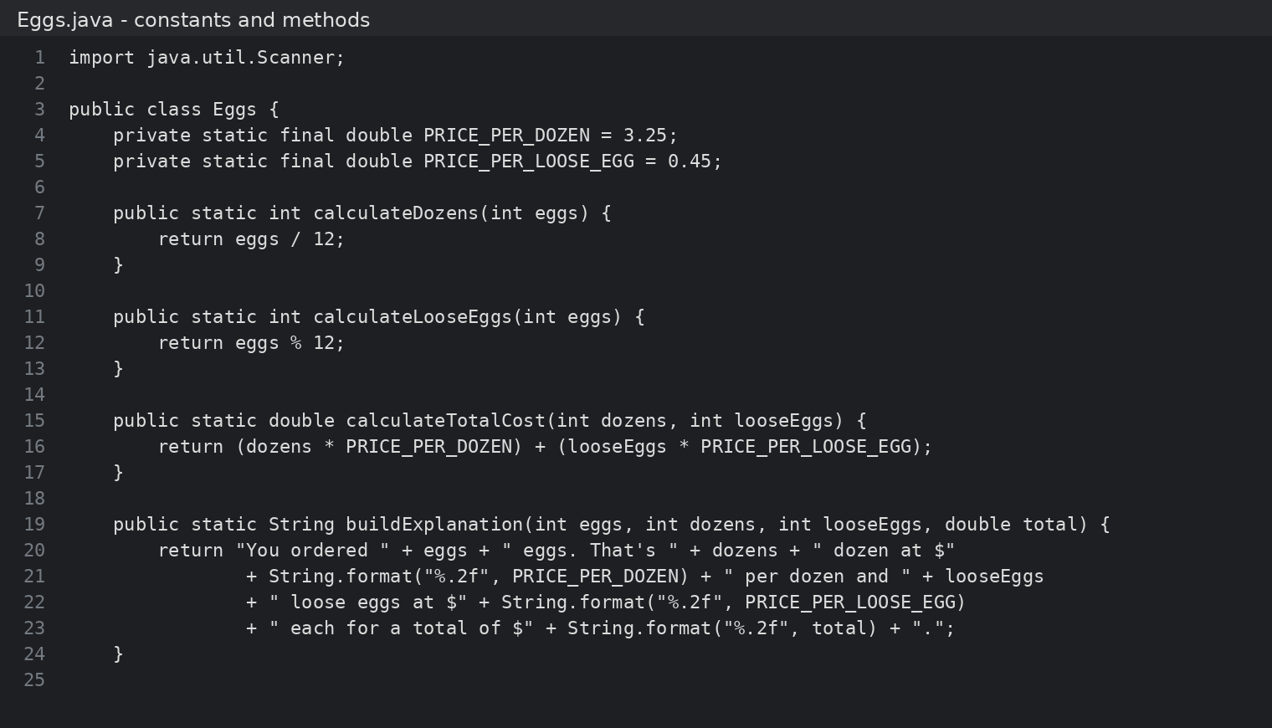
Figure 1. Eggs.java constants and methods screenshot.
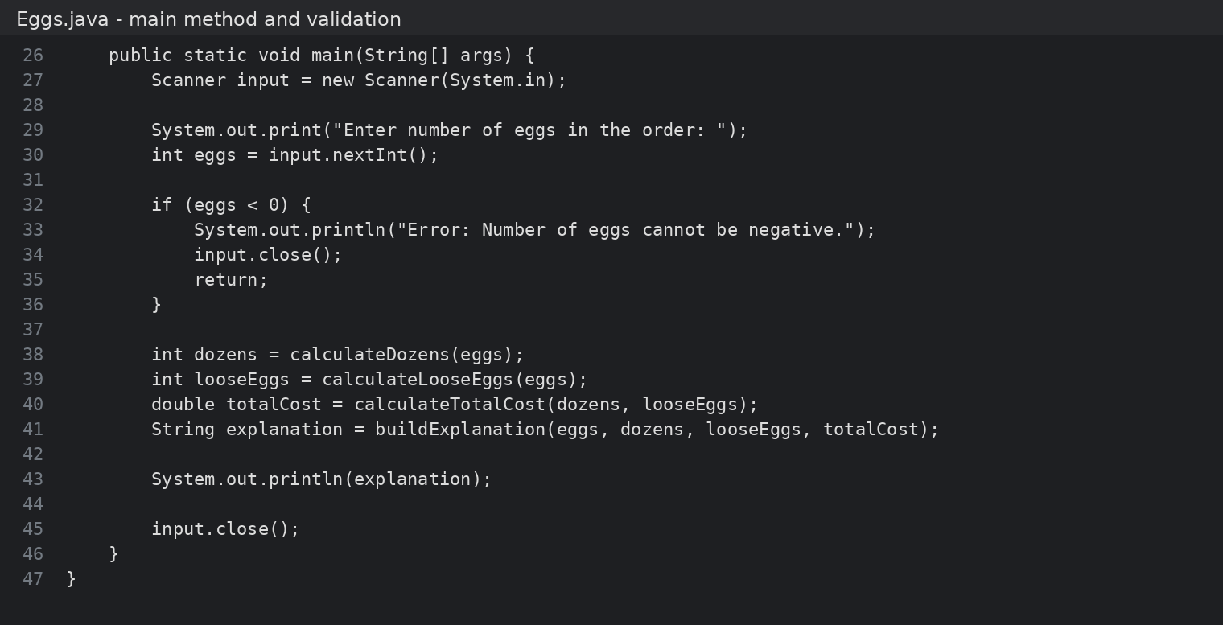
Figure 2. Eggs.java main method and validation screenshot.

Appendix B

Program Output Screenshot
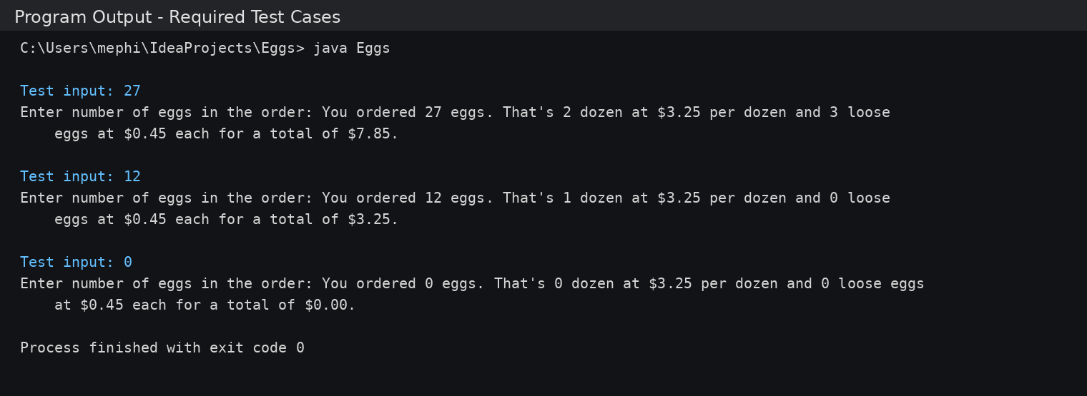
Figure 3. Successful program output showing all required test cases.

